.

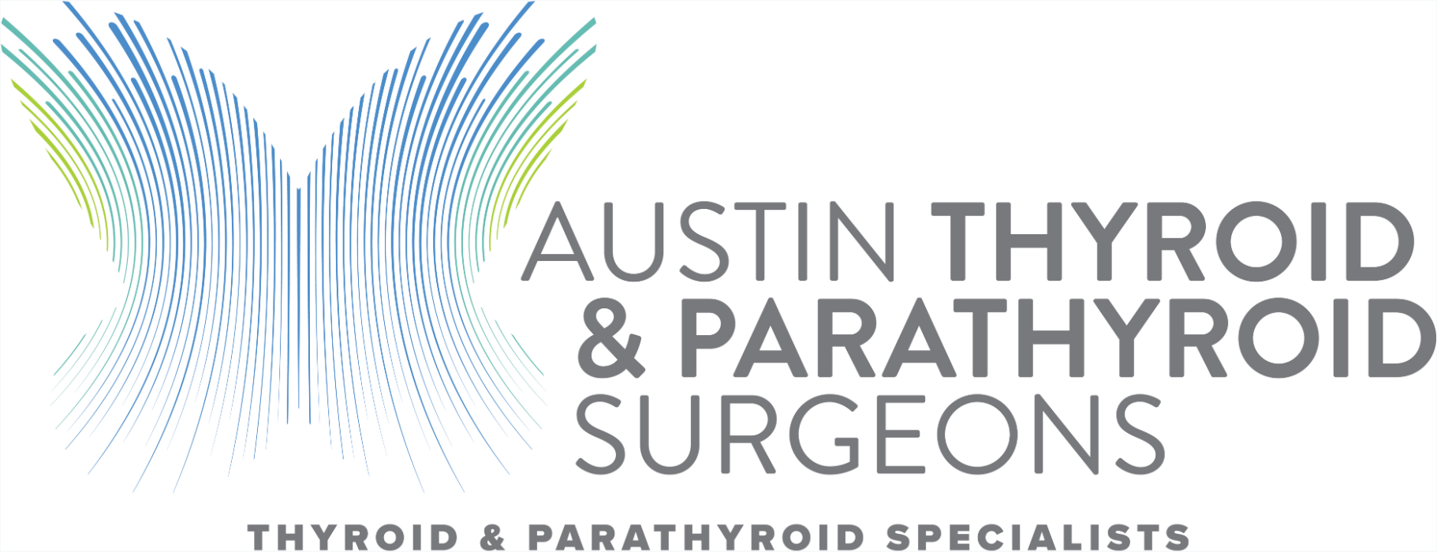

We at Austin Thyroid and Parathyroid Surgeons are proud to present our surgical complication data from this past year.

To summarize:

1. We did not have a single neck hematoma (bleeding in the neck) after any of our operations.

2. We did not have a single patient develop permanent hypoparathyroidism (low calcium levels needing medications several times daily) after surgery. All of our patients were able to wean off calcium after surgery.

3. We only had one patient with permanent vocal cord (recurrent laryngeal nerve) paralysis or voice hoarseness. This patient required resection of the nerve for aggressive thyroid cancer invading it which was unavoidable. The few patients with temporary voice hoarseness resolved with time.

We will continue to offer our transparent data outcomes in the future, and encourage all surgical practices to do the same. Please click the link below to see details of our data results.

www.AustinThyroid&ParathyroidSurgeons.com